

**Object Oriented Programming Lab**

**Name:** Pratham Kandari

**Sap Id:** 500097663

**Batch:** 7

**Experiment -4**

1. Write a Java program to show that private member of a super class cannot be accessed from derived classes.

Ans:

class A

{

private int a=10;

private int b=20;

}

class B extends A

{

void add()

{

int c=a+b;

System.out.println(c);

System.out.println("In Class B");

}

}

class ExperimentFourOne

{

public static void main(String args[])

{

B obj = new B();

obj.add();

}

}

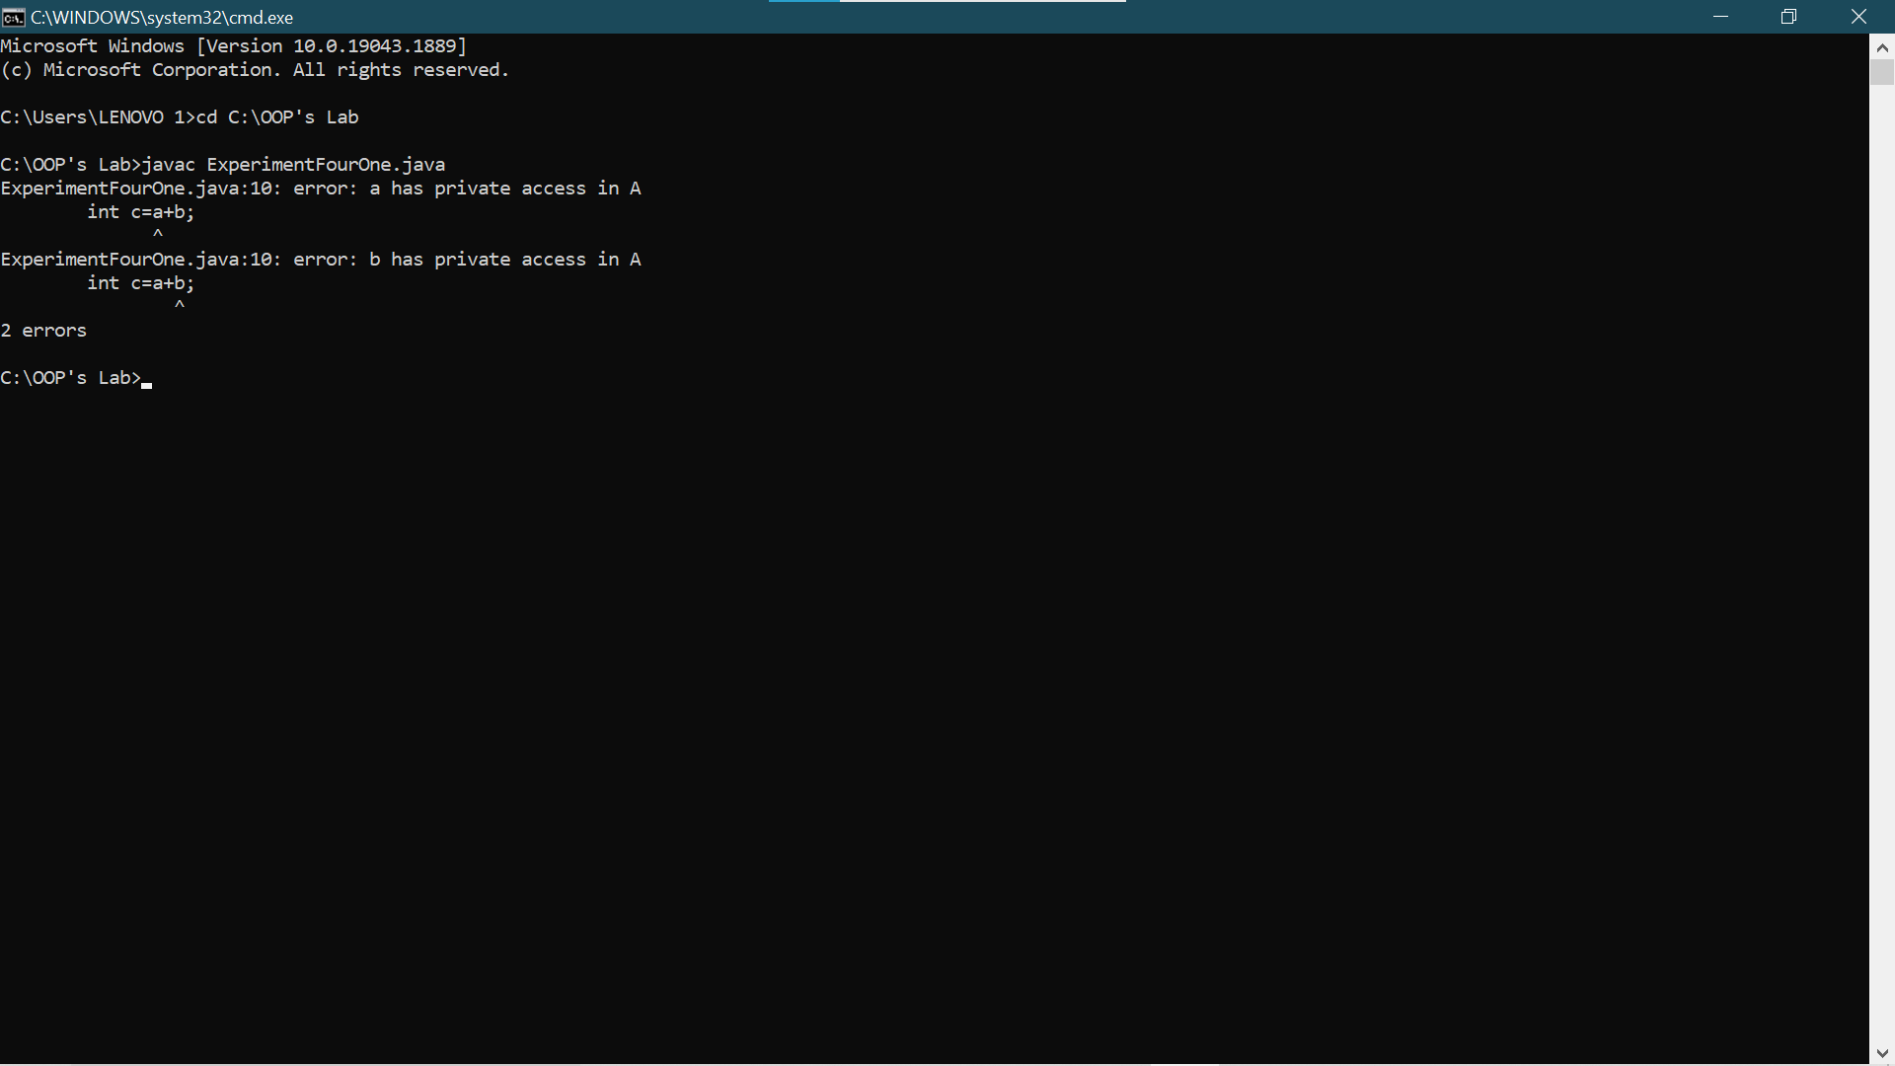

1. Write a program in Java to create a Player class. Inherit the classes Cricket _Player, Football _Player and Hockey_ Player from Player class.

Ans:

class Player

{

void Info()

{

System.out.println("A Player");

}

}

class Cricket_Player extends Player

{

void About()

{

System.out.println("A Cricket Palyer");

}

}

class Football_Player extends Player

{

void msg()

{

System.out.println("A Football Player");

}

}

class Hockey_Player extends Player

{

void Intro()

{

System.out.println("A Hockey Player");

}

}

class ExperimentFourTwo

{

public static void main(String args[])

{

Cricket_Player ob = new Cricket_Player();

ob.About();

ob.Info();

Football_Player ob1 = new Football_Player();

ob1.msg();

Hockey_Player ob2 = new Hockey_Player();

ob2.Intro();

}

}

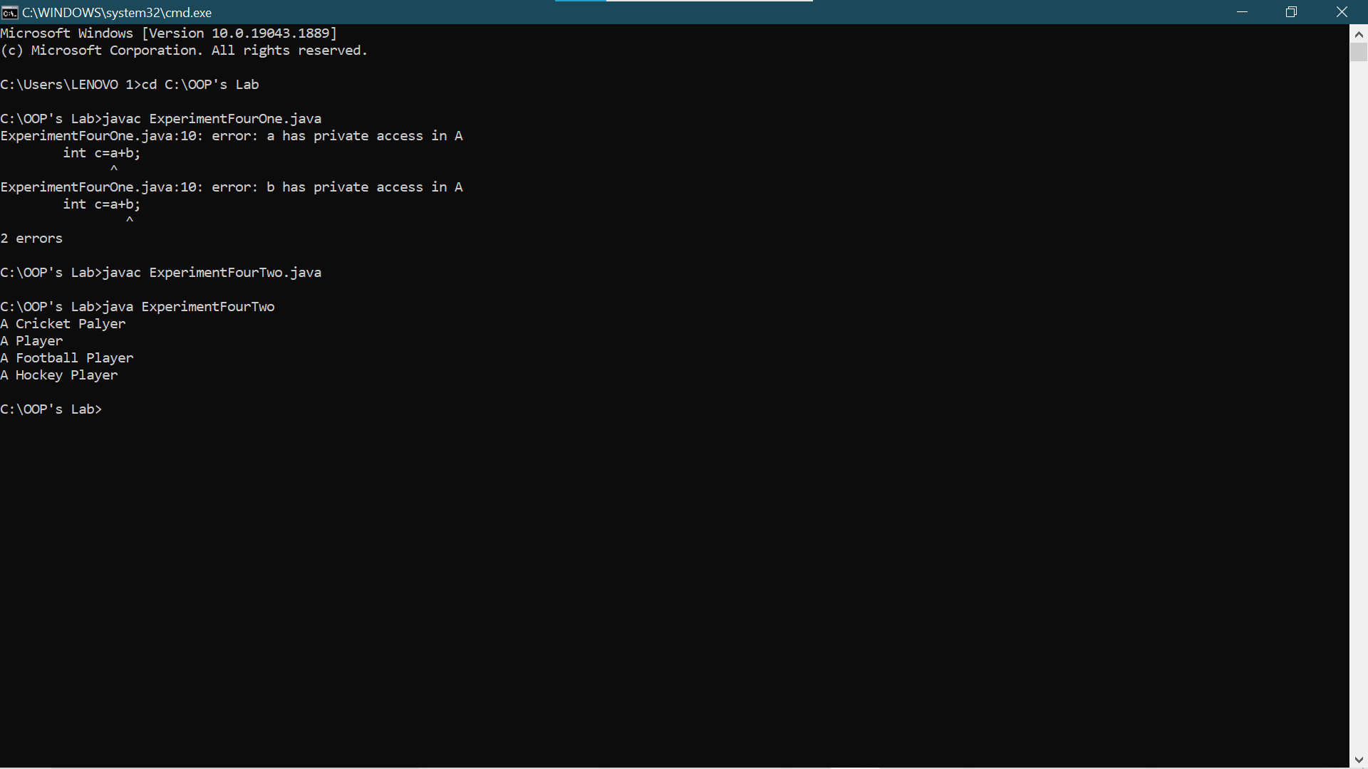

1. Write a class Worker and derive classes DailyWorker and SalariedWorker from it. Every worker has a name and a salary rate. Write method ComPay (int hours) to compute the week pay of every worker. A Daily Worker is paid on the basis of the number of day she/she works. The Salaried Worker gets paid the wage for 40 hours a week no matter what the actual hours are. Test this program to calculate the pay of workers. You are expected to use the concept of polymorphism to write this program.

Ans:

import java.util.*;

class Worker

{

String name;

Worker(String n)

{

name = n;

}

void Show()

{

System.out.println("Name is: "+name);

}

}

class DailyWorker extends Worker

{

int rate;

DailyWorker(String n, int r)

{

super(n);

rate = r;

}

void compay(int hours)

{

Show();

System.out.println("Salary is: "+(hours*rate));

}

}

class SalariedWorker extends Worker

{

int rate;

SalariedWorker(String n, int r)

{

super(n);

rate=r;

}

int hours=40;

void compay()

{

Show();

System.out.println("Salary is: "+(hours*rate));

}

}

class ExperimentFourThree

{

public static void main(String args[])

{

Scanner sc=new Scanner(System.in);

DailyWorker ob = new DailyWorker("Rahul",5);

System.out.println("Enter the hours of the worker");

int hours = sc.nextInt();

ob.compay(hours);

SalariedWorker ob1 = new SalariedWorker("Ohm",10);

ob1.compay();

}

}

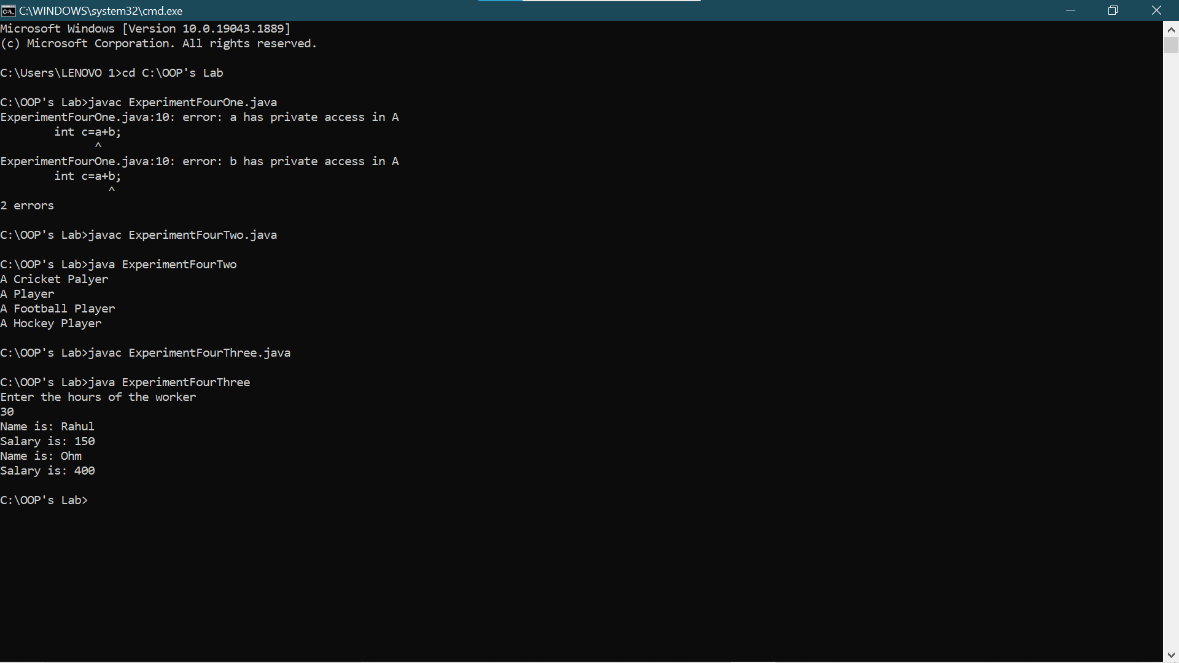

1. Consider the trunk calls of a telephone exchange. A trunk call can be ordinary, urgent or lightning. The charges depend on the duration and the type of the call. Write a program using the concept of polymorphism in Java to calculate the charges.

Ans:

class Trunk_Call

{

int ordinary_rate = 10;

int urgent_rate = 20;

int lightning_rate = 30;

}

class Ordinary extends Trunk_Call

{

void charges(int hours)

{

System.out.println(ordinary_rate*hours);

}

}

class Urgent extends Trunk_Call

{

void charges(int hours)

{

System.out.println(urgent_rate*hours);

}

}

class Lightning extends Trunk_Call

{

void charges(int hours)

{

System.out.println(lightning_rate*hours);

}

}

class ExperimentFourFour

{

public static void main(String args[])

{

Ordinary ob = new Ordinary();

ob.charges(4);

Urgent ob1 = new Urgent();

ob1.charges(5);

Lightning ob2 = new Lightning();

ob2.charges(10);

}

}

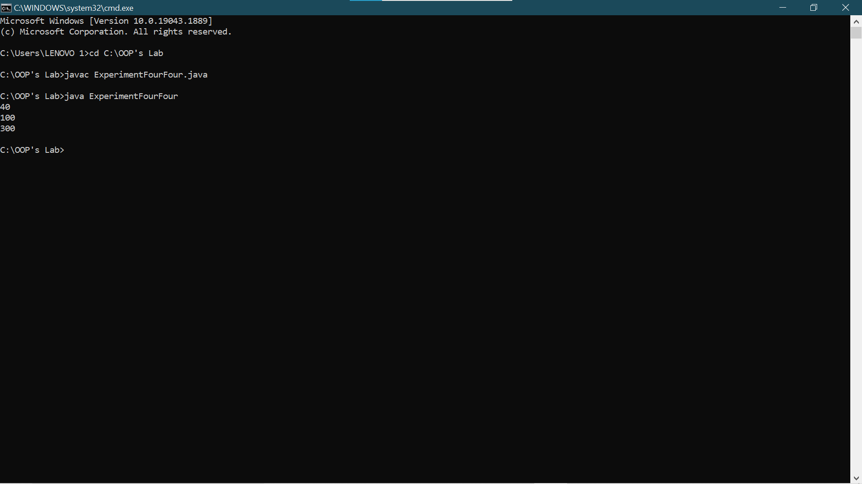

1. Design a class employee of an organization. An employee has a name, empid, and salary. Write the default constructor, a constructor with parameters (name, empid, and salary) and methods to return name and salary. Also write a method increaseSalary that raises the employee’s salary by a certain user specified percentage. Derive a subclass Manager from employee. Add an instance variable named department to the manager class. Supply a test program that uses theses classes and methods.

Ans:

import java.util.*;

class Employee

{

String name;

String empid;

int Salary;

Employee()

{

name="";

empid="";

Salary=0;

}

Employee(String n, String id, int s)

{

name=n;

empid=id;

Salary=s;

}

String names()

{

return name;

}

int Salaries()

{

return Salary;

}

double increaseSalary(double rate)

{

double cal=(Salary*(rate/100));

double new_salary=Salary+cal;

return new_salary;

}

}

class Maanager extends Employee

{

public String department="d";

}

class ExperimentFourFive

{

public static void main(String args[])

{

Scanner sc = new Scanner(System.in);

System.out.println("Enter the name");

String n=sc.nextLine();

System.out.println("Enter the employee id");

String id=sc.nextLine();

System.out.println("Enter the Salary");

int s=sc.nextInt();

System.out.println("Enter the percentage increase in the salary");

double r=sc.nextDouble();

Employee ob = new Employee(n,id,s);

System.out.println(ob.names());

System.out.println(ob.Salaries());

System.out.println(ob.increaseSalary(r));

}

}

